API Model
# Source: AI Source: Provided by: [Data Path: Persons Table -> ID Column: 1, Name_En Column: Motasem Essam] -> From: [ChatGPT] on [1/23/2026]
An API Model (Request/Response Model) represents the data exchanged between systems through APIs.
It defines the structure of requests sent to an API or responses received from an API.
👉 Focused on communication, not business logic or storage

🔑 Key Characteristics
# Source: AI Source: Provided by: [Data Path: Persons Table -> ID Column: 1, Name_En Column: Motasem Essam] -> From: [ChatGPT] on [1/23/2026]
- ✅ Used for incoming requests and outgoing responses
- ✅ Matches the API contract (JSON, XML, etc.)
- ✅ Simple structure, usually no business logic
- ✅ Often mapped to/from DTOs or Domain Models

🧱 Example – Request Model
# Source: AI Source: Provided by: [Data Path: Persons Table -> ID Column: 1, Name_En Column: Motasem Essam] -> From: [ChatGPT] on [1/23/2026]
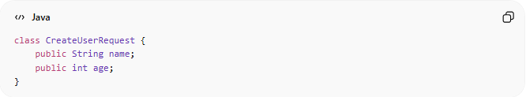
class CreateUserRequest {
public String name;
public int age;
}

🧱 Example – Response Model
# Source: AI Source: Provided by: [Data Path: Persons Table -> ID Column: 1, Name_En Column: Motasem Essam] -> From: [ChatGPT] on [1/23/2026]
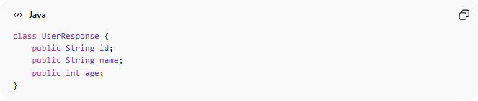
class UserResponse {
public String id;
public String name;
public int age;
}

🔄 Flow
# Source: AI Source: Provided by: [Data Path: Persons Table -> ID Column: 1, Name_En Column: Motasem Essam] -> From: [ChatGPT] on [1/23/2026]
Client ↔ API Model ↔ Controller ↔ Mapper ↔ Domain Model
- Client sends API request → mapped to Domain Model / DTO
- Business logic processes the request → returns Domain Model
- Mapper converts Domain Model → API Response Model → sent to client

❌ Bad Example (Using Domain Entity Directly in API)
# Source: AI Source: Provided by: [Data Path: Persons Table -> ID Column: 1, Name_En Column: Motasem Essam] -> From: [ChatGPT] on [1/23/2026]
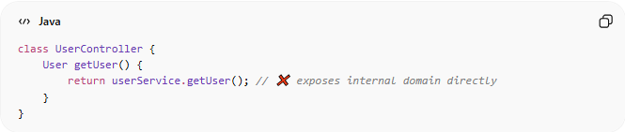
class UserController {
User getUser() {
return userService.getUser(); // ❌ exposes internal domain directly
}
}
👉 Problems:
- Leaks internal structure
- Hard to version API
- Tight coupling between backend and client

✅ Good Example (Using API Model)
# Source: AI Source: Provided by: [Data Path: Persons Table -> ID Column: 1, Name_En Column: Motasem Essam] -> From: [ChatGPT] on [1/23/2026]
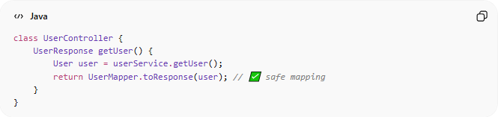
class UserController {
UserResponse getUser() {
User user = userService.getUser();
return UserMapper.toResponse(user); // ✅ safe mapping
}
}

🔄 API Model vs DTO vs Domain Model
# Source: AI Source: Provided by: [Data Path: Persons Table -> ID Column: 1, Name_En Column: Motasem Essam] -> From: [ChatGPT] on [1/23/2026]
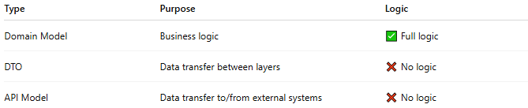
Type | Purpose | Logic
Domain Model | Business logic | ✅ Full logic
DTO | Data transfer between layers | ❌ No logic
API Model | Data transfer to/from external systems | ❌ No logic

💡 Key Idea
# Source: AI Source: Provided by: [Data Path: Persons Table -> ID Column: 1, Name_En Column: Motasem Essam] -> From: [ChatGPT] on [1/23/2026]
API Model = communication contract — defines exactly what data clients send/receive

🧾 Summary
# Source: AI Source: Provided by: [Data Path: Persons Table -> ID Column: 1, Name_En Column: Motasem Essam] -> From: [ChatGPT] on [1/23/2026]
- Used for requests/responses in APIs
- Maps to/from Domain Model or DTO
- Contains no business logic
- Keeps API stable, decoupled, and versionable

